Pizza Sales SQL Queries
A.KPI’S
1.Total Revenue:
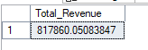
2.Average order Value
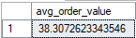
3.Total pizzas sold
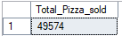
4.Total orders placed
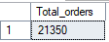
5.Top 5 pizzas with highest price
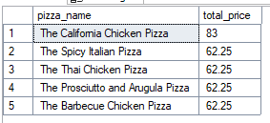
6. Unique Pizza Categories
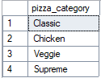
7. Filtering all the records where pizza_category is classic
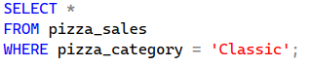
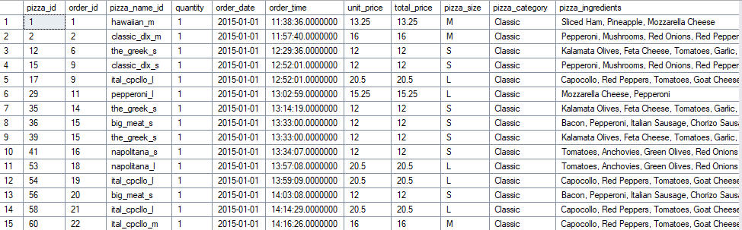
8. The top 10 highest-value sales
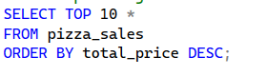
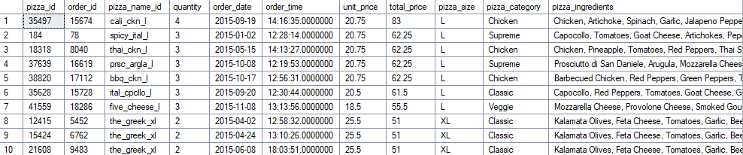
9.Total pizza Sales by category
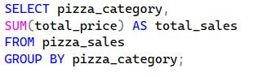
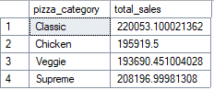
10.Average Price per category
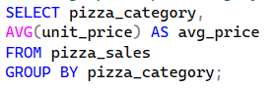
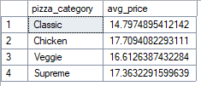
11.Total Quantity Sold per Category
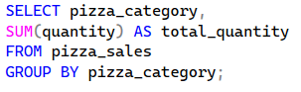
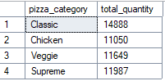
12.Pizza Categories that generate more than 1 lakh in sales
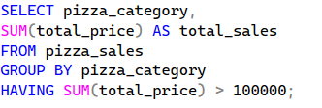
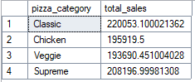
13.All orders placed in January 2015
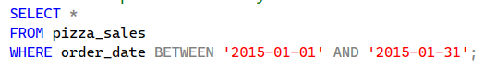
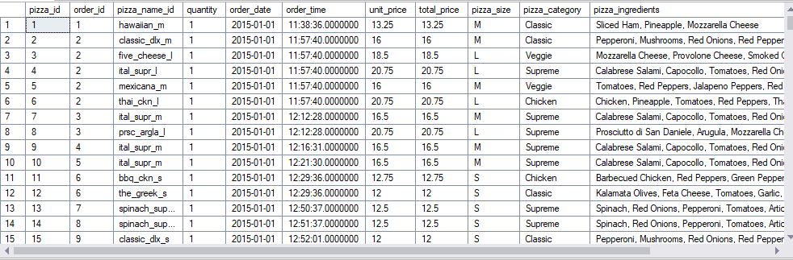
14.Pizzas that have cheese in their names
